Parker B. Francis Fellowship Program
Class of 2022

Adeel A. Abbasi, MD
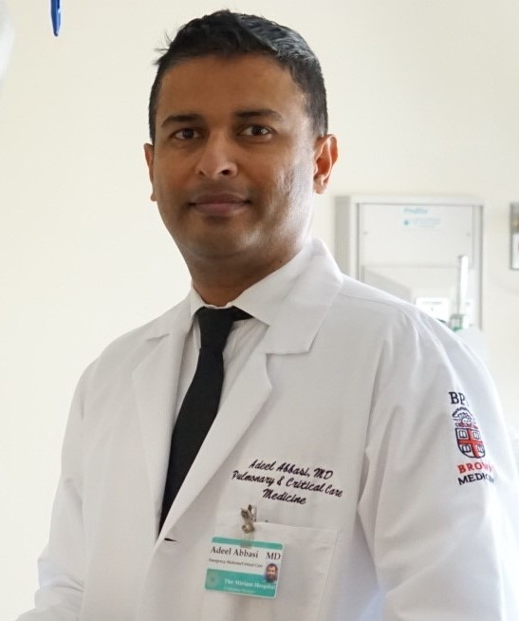

Hemorrhage and Thrombosis in Patients Treated with Extracorporeal Life Support

Extracorporeal life support is a life-saving medical treatment used to help patients with heart and lung failure. During the current pandemic, it has been used to treat over 9,000 critically ill patients with COVID-19 related heart and lung failure worldwide. Bleeding and clotting are the most feared complications of, and the most common cause of death on, this treatment. We cannot currently identify patients at risk for hemorrhage and thrombosis. A better understanding of the risk factors involved could help predict and prevent these devastating complications and improve patient survival. My research will use artificial intelligence to help identify these important risk factors, and study new potential blood tests to detect and predict these complications in patients.

Mentor: Corey E. Ventetuolo, MD, MS
Institution: Memorial Hospital of Rhode Island

Snigdha Jain, MD


Socioeconomic Disadvantage and Post-ICU Disability: The Role of Rehabilitation

Older persons enrolled in Medicaid have greater difficulty in activities of daily living, or “disability” after surviving an ICU stay. Rehabilitation therapy can potentially reduce this disability. However, it is not known whether older ICU survivors with lower income, education, or insurance receive less rehabilitation and if this affects subsequent disability. Here, we will examine whether socioeconomically disadvantaged older persons receive less rehabilitation services during and following ICU hospitalization and if this leads to greater post-ICU disability among them. Our results will help providers and health systems identify vulnerable patient groups and care settings where rehabilitation services need to be targeted to reduce disparities in disability after an ICU stay.

Mentor: Lauren E. Ferrante, MD, MHS
Institution: Yale University

Elizabeth M. Corteselli, PhD

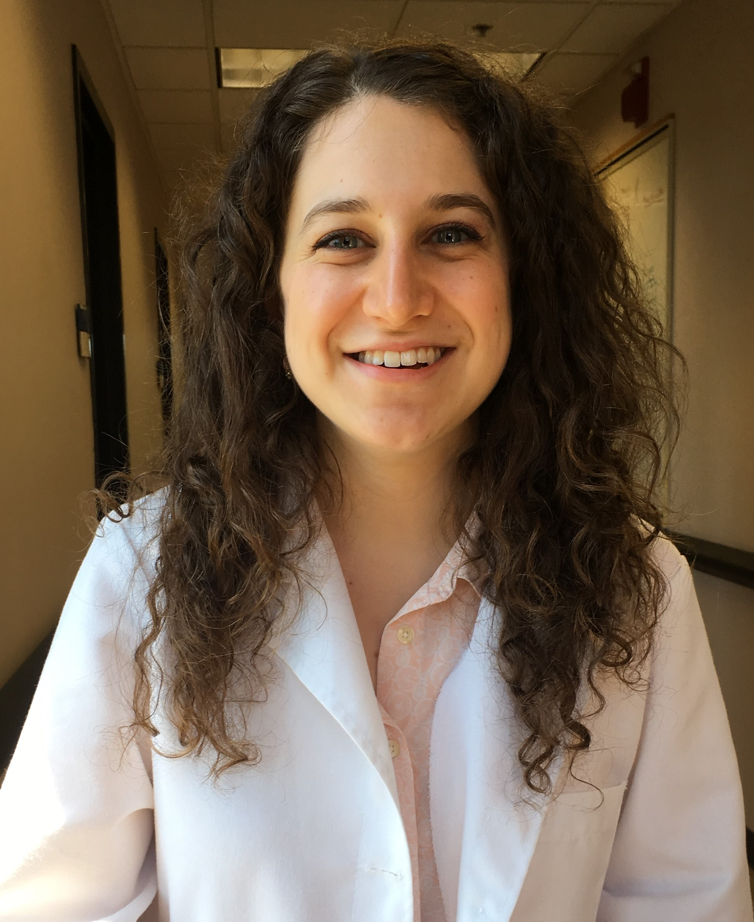

Oxidative Inactivation of Cathepsin B, Disruption of Airway Epithelial Cell Plasticity and Pulmonary Fibrosis

Idiopathic pulmonary fibrosis (IPF) is a progressive disease with no known cure, few treatment options, and a high mortality rate. We have previously observed that IPF lungs contain an elevated level of a type of protein oxidation involving attachment of glutathione, termed glutathionylation. In addition, the enzyme responsible for removal of this modification, glutaredoxin (GLRX), is decreased in IPF lungs. This project will evaluate how glutathionylation of cathepsin B, an enzyme with an essential role in protein turnover, influences lung repair in IPF. We are excited as this research will help establish a mechanism of action for the use of GLRX as a novel biologic for treatment of fibrosis.

Mentor: Yvonne Janssen-Heininger, PhD
Institution: University of Vermont

David R. Price, MD
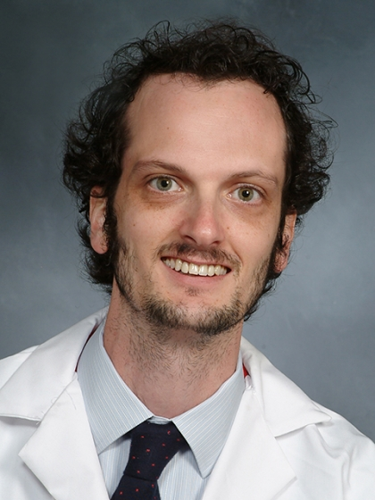

Necrotic Cell Death and Vascular Injury in Acute Respiratory Distress Syndrome

We study a population that challenges the dogma that neutrophils are essential to acute respiratory distress syndrome (ARDS). Termed neutropenic ARDS, this population lacks circulating immune cells but is paradoxically more “inflamed” than ARDS subjects with normal immune systems. We recently reported profound immune dysregulation in neutropenic ARDS, and we believe this immune signaling can trigger vascular cell death. In this proposal, we seek to study how the cell death protein receptor interacting protein kinase-3 (RIPK3) interacts with other relevant vascular proteins, including the barrier protein angiopoietin-2 (ANGPT2) to limit further vascular injury. We will link these vascular proteins to other circulating proteins as well as to important clinical outcomes and explore the role of RIPK3 in lung injury development.

Mentor: Augustine M.K. Choi, MD
Institution: Weill Medical College of Cornell University

Oluwabukola T. Gbotosho, PhD


Regulation of ET-1 expression by IncRNA and Development of PH in SCD

Sickle cell disease (SCD) affects millions, and pulmonary hypertension (PH) is a major mortality threat in 10 % of them. PH affects the blood pressure in arteries of the lungs, causing the heart to work harder, and over time, results in heart failure. Our research suggests that high levels endothelin-1 (ET-1) contribute to PH in SCD. We have found a non-traditional molecule, a long non-coding RNA, expressed in endothelial cells, that regulates ET-1, and then used a DNA-editing technology (CRISPR/Cas9) to decrease ET-1 in mice. We plan to transplant these mice with SCD to study how the decrease of ET-1 effects PH in these mice. These experiments could allow us to develop a novel molecular inhibitor for ET-1 as a treatment for PH.

Mentor: Punam Malik, MD
Institution: Cincinnati Children’s Hospital Medical Center

Jason M. Szafron, PhD
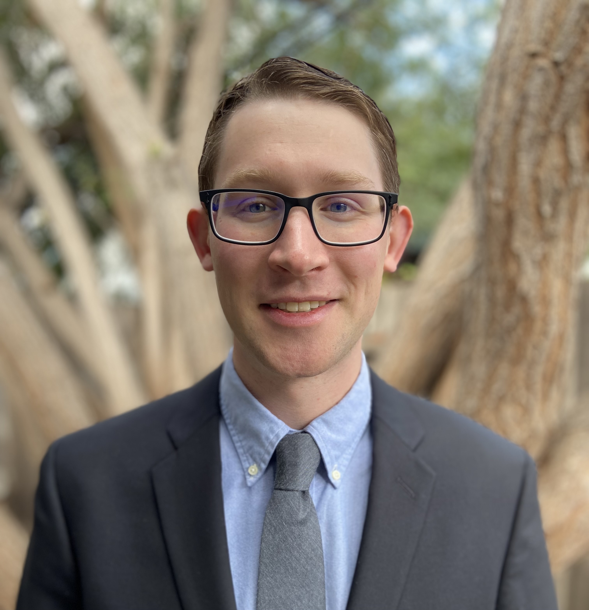

Discovering mechanobiological mechanisms driving pulmonary arterial hypertension
High blood pressure in the lungs makes the heart work harder to pump against the increased load, which eventually causes heart failure and death. In children, this disease can progress in a matter of months and treatment options are limited. Cells within the lung sense the frictional force from blood flow and eventually become dysfunctional when this force changes from the normal level. However, this force is difficult to measure directly. I aim to build a computer model that simulates the frictional forces and then predicts how they affect cell behavior and the blood vessel wall. I hope the model can be used to identify new treatment targets for interrupting the cells’ transition to a dysfunctional state and prevent disease progression.

Mentor: Alison L. Marsden, PhD
Institution: Stanford University

William Z. Zhang, MD



Alveolar Macrophage Iron-induced Dysfunction in COPD Pathogenesis

Chronic obstructive pulmonary disease (COPD) is the 3rd leading cause of death worldwide and affects over 170 million people globally. Although cigarette smoke exposure is the leading risk factor for developing COPD, how smoke causes progressive lung damage in COPD is poorly understood. We have found evidence that suggests a link between smoke and abnormal accumulation of iron in alveolar macrophages, lung immune cells which are known to cause destruction of lung tissue in COPD. In this proposal, we will develop and confirm this biological connection between iron and alveolar macrophages and demonstrate the clinical impact of alveolar macrophage iron overload on COPD development using a large multicenter COPD study, with the goal of eventually developing therapy that could target this important pathway.

Mentor: Fernando J. Martinez, MD
Institution: Weill Medical College of Cornell University

Adam M. Andruska, MD, MSE
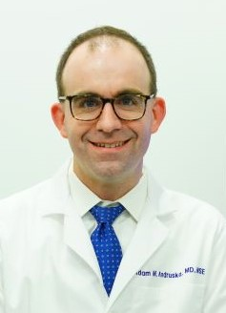

Identifying T cell-vascular signaling as a driver of pulmonary hypertension.

Pulmonary arterial hypertension (PAH) is a disabling and fatal illness without cure occurring both alone and as a complication of other disease, such as autoimmune conditions or congenital heart disease. In PAH, cells block the lung blood vessels and cause progressive heart failure. Inflammatory white blood cells known as T-Cells surround the blood vessels as these blockages occur. Studies have shown that sub-types of T-Cells can both harm and protect lung blood vessels in PAH. This proposal investigates which signals sent from T-Cells are driving the formation of blockages in the lung vasculature. This will deepen our understanding of the role of the immune system in PAH development and may identify signals that can be blocked in patients to slow or reverse PAH development.

Mentor: Edda F. Spiekerkoetter, MD
Institution: Stanford University

Jamie E. Meegan, PhD


Oxidation of LDL by CFH and lung microvascular hyperpermeability during sepsis

Sepsis is a life-threatening disease in which the body’s reaction to an infection is too extreme, with no specific treatments. Inflammation during sepsis leads to blood vessel damage, allowing leak of fluid and toxic substances into tissues, leading to organ failure and death. Identifying how blood vessel damage occurs during sepsis could lead to better treatment. Our research has shown that cell-free hemoglobin (CFH) released from damaged red blood cells contributes to blood vessel and organ damage. CFH may cause damage through oxidizing low-density lipoprotein (LDL). This proposal aims to determine the role of oxidized LDL by CFH in blood vessel damage and lung injury during sepsis. These studies could reveal new targets for treating organ damage during sepsis, potentially lowering high disability and death.

Mentor: Lorraine B. Ware, MD
Institution: Vanderbilt University Medical Center

Sagar P. Bapat, MD, PhD
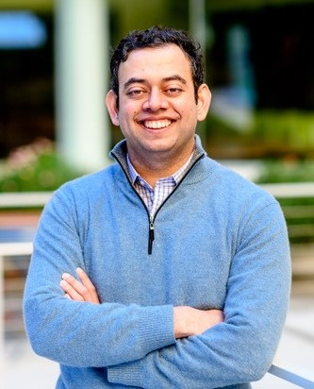

Precision Immunology of Asthma: Understanding Immune Responses in Obesity

Obesity is a major and growing public health problem, characterized by several co-morbidities including type 2 diabetes mellitus, cardiovascular disease, renal disease, liver disease, and particular types of cancer. Recent clinical and epidemiological studies have also highlighted obesity as a major risk factor for the development of asthma. This form of obesity-associated asthma generally does not respond well to conventional asthma therapies. Therefore, I propose to study the molecular pathophysiology of obesity-associated asthma to find ways to better manage this disease.

Mentor: Alexander Marson, MD, PhD
Institution: University of California, San Francisco, and Gladstone Institutes

