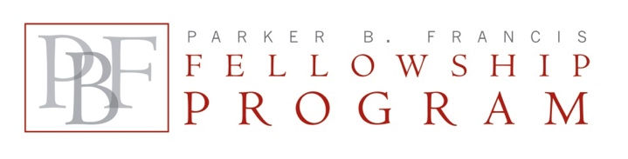
ANNUAL FINANCIAL REPORT

Reports are to cover the fellowship year, July 1 – June 30. A financial report is due on October 31, after each full year of the Fellowship, including Year 1.

Please send completed and signed form to: | Shari Hockenbery, CMP, Program Specialist  Francis Family Foundation  800 West 47th Street, Suite 717 / Kansas City, MO 64112  Email: shari@francisfoundation.org

Sponsoring Institution
Mentor’s Name, degree(s)
(first, middle, last name, degrees)
Fellow’s Name, degree(s)
(first, middle, last name, degrees)
Fellow’s actual research % effort
(not % salary paid with PBF funding)
PBF Fellowship start-end dates  (e.g., 7/14 – 6/17) |  | Report Period  (e.g., Yr2, 7/15-6/16)

Cost category | Costs for year
PBF Fellow’s salary
PBF Fellow’s Fringe benefits
Fellow’s Travel ($2000 limit)
Total Costs

PBF Fellowship Budget Report
for Fellowship Year | (1, 2 or 3) | Ending June 30 | Type year here

Carry forward from prior yr | $ | PBF Award for year | $ | Total PBF Funding | $
Total Costs for the year |  |  |  |  | $
Balance |  |  |  |  | $

Person to contact regarding this report | Email Address | Telephone

NOTE: Please do NOT refund carry-forward balances. The final check, issued in December of Year 3 of the fellowship, will be reduced by the carry-forward amount reported in the last annual financial report. For the final award year, refund the total balance only if the balance exceeds $1,000.

Sponsor Signature |  | Printed Name |  | Date
Financial Officer Signature |  | Printed Name |  | Date

